Children’s Cancer Institute
Zero Childhood Cancer (ZERO)
DATA ACCESS APPLICATION FORM
(European Genome-phenome Archive)

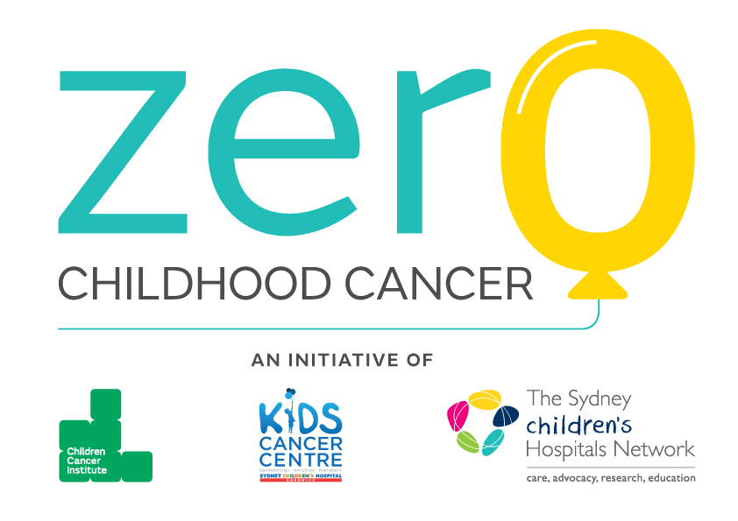
Version 1.0 August 2020 EGA
Prepared by the ZERO Childhood Cancer Research Committee
(ZERO DAC)

Zero Childhood Cancer (ZERO) Data Access Application Form

BACKGROUND

Zero Childhood Cancer
The Zero Childhood Cancer Program (ZERO) is a joint initiative of the Children’s Cancer Institute, and Kids Cancer Centre, at the Sydney Children’s Hospital, Randwick. Children with very high-risk cancer (<30% chance of 5-year survival) are recruited to the study, subject to comprehensive molecular profiling, and treatment results returned in real-time. The first phase of ZERO was the TARGET study (2015-7; n=58 patients), followed by PRISM (n=400 patients; 2017-20).

Description of the molecular profiling data and sequencing partners
ZERO’s molecular profiling platform includes whole genome sequencing (WGS), RNA sequencing (RNASeq) and methylation array data and aggregate base clinical information from children with very high risk cancer of various tissue origins.

Whole Genome Sequencing (WGS) was performed on Illumina HiSeq X sequencers at the Garvan Institute of Medical Research (Sydney, Australia) in a clinically accredited laboratory (ISO15189). Tumour DNA was sequenced to 90-120x depth (3 lanes of HiSeq X), and matched germline to 30-40x depth (1 lane).

Whole transcriptome RNA Sequencing (80M read pairs, or 40M for TARGET) is performed on the Illumina NextSeq500 platform at the Murdoch Children’s Institute, Melbourne (MCRI).

Methylation analysis using Illumina’s Infinium Human Methylation EPIC BeadChip is performed on the Illumina iScan. The EPIC BeadChip assesses methylation at over 850,000 CpGs throughout the human genome.

Whole genome, transcriptome and methylome profiling enhances actionable target discovery in high-risk paediatric cancer
To access data from Wong, Mayoh and Lau et al, 2020 Nature Medicine, researchers are invited to complete this Data Access Application (DAA) to gain access to comprehensive omics datasets together with minimal clinical information to support high-level integrative analysis. This application is based on the exacting standards of the European Genome-Phenome Archive. Raw data (fastq.gz and idat) and processed data (VCF, TXT) data are available from tumours and matched germline controls.

Data Access Policy
To maintain participant privacy and confidentiality, whilst maximising ZERO utility, we have deployed a controlled access data management system that makes de-identified minimal clinical information available together with individual omics data either as processed data (VCF or TXT format) or unprocessed data (FASTQ format), dependent on the justification criteria being met.
Completion of the ZERO DAA (Section 2) and execution of the Data Transfer Agreement (DTA) (Sections 3 & 4) is required before access to Controlled Data will be granted. The ZERO Data Access Committee will aim to review completed applications within 3 weeks. Acceptance or rejection of request will be communicated to the investigator named on this application. Upon approval, controlled access can then be immediately made available to the applicant.

File Access
Once downloaded, minimum protection measures are required to protect all ZCC data. Data can be held in unencrypted files on an institutional computer system, with the equivalent of UNIX user group read/write access for one or more appropriate groups but not UNIX world read/write access behind a secure firewall. Laptops holding this data should have password protected logins and screen locks (set to lock after 5 min of inactivity). If held on USB keys or other portable hard drives, the data must be encrypted.

DATA ACCESS APPLICATION

Project/Request Overview
Type of data required
WGS Tumour | ☐ | Minimal Clinical information | ☐
WGS Germline | ☐ | Methylation Tumour | ☐
RNASeq Tumour | ☐

Provide a brief overview of the proposed project with specific emphasis on what type of information is being requested and how ZCC data will be used, as well as the proposed timeframe for the project (500 words maximum).
Click or tap here to enter text.

Omics
Select the ZERO data format required for the proposed project.
Germline WGS SNV+indel (Haplotype Caller) | VCF | ☐ | gVCF | ☐
Germline WGS FASTQ | FASTQ.GZ | ☐
Somatic WGS SNV+indel (Strelka) | VCF | ☐
Somatic WGS CNV (PURPLE) | TXT | ☐
Somatic WGS SV (GRIDSS) | VCF | ☐
Tumour WGS FASTQ | FASTQ.GZ | ☐
Tumour RNA FASTQ | FASTQ.GZ | ☐
Tumour RNA expression | TXT | ☐
Tumour Methylation | iDAT | ☐
Should FASTQ data be requested – provide appropriate justification as to why this format (unprocessed rather than processed) is necessary for the purpose of the proposed project.
Click or tap here to enter text.

Provide detail as to how ZERO data will be stored and what security measures are in place to ensure conformity with the conditions stipulated in Section 1.3
Click or tap here to enter text.

Provide the name of the human research ethics committee approving the research and the approval number and expiry date.
Please attach the relevant ethics approval letter as supporting documentation.
HREC/IRB/ERB/REB Committee: Click or tap here to enter text.

Approval Number: Click or tap here to enter text.

Expiry Date: Click or tap here to enter text.

Clinical Information for Researchers
Clinical data (Controlled Access) for ZERO are listed below – select the data required for the proposed project.
Diagnosis | ☐ | Disease | ☐
Sex | ☐ | Stage | ☐
Age at diagnosis | ☐

User Institution (“Recipient”)
Institution Name: Click or tap here to enter text.
Address: Click or tap here to enter text.
Phone: Click or tap here to enter text.

Principal Investigator (“User”)
Name: Click or tap here to enter text.
Address: Click or tap here to enter text.
Phone: Click or tap here to enter text.
Email: Click or tap here to enter text.

Authorised Personnel
(Personnel at the User Institution to be granted access to the Data).

Name | Position/  Job Title | Department/  Division | Email/  Phone
Click or tap here to enter text. | Click or tap here to enter text. | Click or tap here to enter text. | Click or tap here to enter text.
Click or tap here to enter text. | Click or tap here to enter text. | Click or tap here to enter text. | Click or tap here to enter text.
Click or tap here to enter text. | Click or tap here to enter text. | Click or tap here to enter text. | Click or tap here to enter text.
Click or tap here to enter text. | Click or tap here to enter text. | Click or tap here to enter text. | Click or tap here to enter text.

DATA TRANSFER AGREEMENT (DTA) TERMS AND CONDITIONS
The ZERO Data Access Committee (ZERO DAC) has been established by the organisations jointly leading the Zero Childhood Cancer Personalised Medicine Program, Kids Cancer Centre, Sydney Children’s Hospital Network and Children’s Cancer Institute (CCI) (collectively the ZERO Partners). The ZERO DAC has responsibility for assessing applications to access data.

CCI enters into this Data Transfer Agreement on behalf of the ZERO Partners.

The User Institution (the institution named in Section 2.4) agrees with CCI, that access to and use of the ZERO dataset specified in Sections 2.2 and 2.3 will be governed by the following terms and conditions.

If the Recipient fails to comply with these Terms and Conditions, CCI may terminate this agreement and require immediate return or destruction of any Data supplied.

The User Institution agrees to be bound by these terms and conditions.
3.1 Definitions
Authorised Personnel means the individuals at the User Institution to whom the ZERO DAC grants access to the Data including the User listed in Section 2.5 and the individuals listed in Section 2.6 and any other individuals for whom the User Institution subsequently requests access to the Data.

Data means the managed access datasets to which the User Institution has requested access as set out in Sections 2.2 and 2.3.

External Collaborator means a collaborator of the User, working for an institution other than the User Institution.

Intellectual Property or IP means all intellectual and industrial property whether registrable or not, throughout the world, including, without limitation:

- patents, trademarks, service marks, copyright, registered designs, trade names, symbols and logos;
- patent applications and applications to register trademarks, service marks and designs;
- all formulae, methods, plans, data, drawings, specifications, characteristics, equipment, designs, inventions, discoveries, improvements, know-how, experience, software products, trade secrets, and other information used by a party in the course of its business; and
- all copyright works (as that term is understood under the Copyright Act 1968 (Cth) and related legislation around the world) owned by a party not otherwise covered by this definition.

Project means the project for which the User Institution has requested access to these Data as set out in Section 2.1.

Publication means, without limitation, articles published in print journals, electronic journals, reviews, books, posters and other written and oral presentations of research.

Recipient means the User Institution listed in Section 2.4.

Research Participant means an individual whose data form part of the Data.

Research Purpose means academic research not for commercial application that seeks to advance the understanding of genetics and genomics, including the treatment of disorders, and work on statistical methods that may be applied to such research.

User means the Principal Investigator for the Project listed in Section 2.5.

ZERO Partners means the Kids Cancer Centre, Sydney Children’s Hospital Network and Children’s Cancer Institute.

ZERO Data means the controlled access of all data sets including genomic, methylation, in-vitro and in-vivo and clinical data generated by the ZERO Partners.

3.2 The User Institution agrees to only use the Data for the purpose of the Project stated in the DAA and only for Research Purposes. The User Institution warrants that the Project for which ZERO data are being sought has been approved by a human research ethics committee (HREC)/institutional review board (IRB), also known as an independent ethics committee (IEC), ethical review board (ERB), or research ethics board (REB).

3.3 The User Institution agrees to preserve, at all times, the confidentiality of the Data. In particular, it undertakes not to use, or attempt to use the Data to compromise or otherwise infringe the confidentiality of information on Research Participants. Without prejudice to the generality of the foregoing, the User Institution agrees to use at least the measures set out in Section 1.4 to protect the Data.

3.4 The User Institution agrees to protect the confidentiality of Research Participants in any research paper or publication that is prepared using the Data by taking all reasonable care to limit the possibility of identification.

3.5 The User Institution agrees not to link or combine the Data to other information or archived data available in a way that could re-identify the Research Participants, even if access to that data has been formally granted to the User Institution or is freely available without restriction.

3.6 The User Institution agrees only to transfer or disclose the Data, in whole or part, or any material derived from the Data, to the User and Authorised Personnel (as defined in Section 2). Should the User Institution wish to share the Data with an External Collaborator, the External Collaborator must complete a separate application for access to the Data.

3.8 The User Institution agrees that the ZERO Partners, and all other parties involved in the creation, funding or protection of the Data:
a) make no warranty or representation, express or implied as to the accuracy, quality or comprehensiveness of the Data;
b) exclude to the fullest extent permitted by law all liability for actions, claims, proceedings, demands, losses (including but not limited to loss of profit), costs, awards damages and payments made by the Recipient that may arise (whether directly or indirectly) in any way whatsoever from the Recipient’s use of the Data or from the unavailability of, or break in access to, these Data for whatever reason and;
c) bear no responsibility for the further analysis or interpretation of these Data.

3.9 The User Institution agrees to follow the Publication Policy set out in Section 4.

3.10 None of the ZERO Partners will have any right, title or interest in any Intellectual Property (IP) that is developed, created or invented in the course of the Project unless one or more of the ZERO Partners has contributed to its development, creation or invention. If that is the case the IP will be jointly owned by the contributing parties as tenants in common in shares proportionate to their respective intellectual contribution to the development, creation or invention of that IP. The joint owners will in good faith consult and decide on measures to be taken to protect and exploit that IP.

3.11 The User Institution agrees that the Data remains the property of the ZERO Partners, and agrees not to make IP claims on the Data and not to use IP protection in ways that would prevent or block access to, or use of, any element of the Data, or conclusions drawn directly from the Data or any of it.

3.12 The User Institution must notify the ZERO DAC of any patent application filed in respect of the Project at the time of filing and provide the ZERO DAC (or its nominee) with sufficient information to determine whether there has been a breach of clause 3.11. If there has been a breach of clause 3.11 then the User Institution must amend its patent application to eliminate the breach or withdraw it. The information provided to ZERO DAC pursuant to this clause will be treated as confidential to the User Institution.

3.13 The User Institution agrees to destroy/discard the Data held, once it is no longer required for use in the Project, unless obliged to retain the Data for archival purposes in conformity with audit or legal requirements.

3.14 The User Institution will notify CCI within 30 days of any changes to or departures of Authorised Personnel.

3.15 The User Institution will notify CCI as soon as it becomes aware of a breach of the terms or conditions of this agreement.

3.16 CCI may terminate this agreement by written notice to the User Institution. If this agreement terminates for any reason, the User Institution will be required to destroy any Data held, including copies and backup copies. This clause does not prevent the User Institution from retaining the Data for archival purposes in conformity with audit or legal requirements.

3.17 The User Institution accepts that it may be necessary for CCI to alter the terms of this agreement from time to time. In the event that changes are required, CCI or its appointed agent will contact the User Institution to inform it of the changes and the User Institution may elect to accept the changes or terminate the agreement by written notice to the other party to this agreement.

3.18 If requested, the User Institution will allow data security and documentation to be inspected by an agent of CCI to verify that it is complying with the terms of this agreement.

3.19 The User Institution agrees to distribute a copy of these terms to the Authorised Personnel. The User Institution will use its best endeavours to ensure that the Authorised Personnel comply with the terms of this agreement.

3.20 This agreement (and any dispute, controversy, proceedings or claim of whatever nature arising out of this agreement or its formation) shall be construed, interpreted and governed by the laws of News South Wales, Australia and the parties submit to the exclusive jurisdiction of the courts that operate in New South Wales.

PUBLICATION POLICY
The User Institution must include an appropriate acknowledgement, and co-authorship if applicable, in any publication that makes use of or reference to a ZERO dataset in accordance with the following terms. Publications that make use of Controlled Access data will be required to acknowledge the ZERO Partners in the acknowledgements section of the Publication.
Should the User Institution wish to add any personnel from a ZERO Partner to the list of authors, the User Institution agrees to forward the Publication to the ZERO DAC for approval prior to submission. Manuscripts or presentations may be submitted to ZERO@ccia.org.au for review. Authors are also encouraged to recognise the contribution of the appropriate cohort convenors via the acknowledgements section in their Publication.
Accepted manuscripts or conference abstracts must be notified and provided to ZERO via ZERO@ccia.org.au.
An example of a proper attribution is:
"The results <published or shown> here are in whole or part based upon data generated by the Zero Childhood Cancer Program Partners.”

Executed as an Agreement.
Both parties confirm that they have read, understood and accept the terms and conditions outlined in this Application.

SIGNED on behalf of the USER INSTITUTION, by its duly authorised officer: |  | Click or tap here to enter text.
 |  | Signature of officer
 |  | Click or tap here to enter text.
 |  | Name
 |  | Click or tap here to enter text.
 |  | Date

SIGNED for on behalf of THE ZERO PARTNERS, by a duly authorised officer of the Children’s Cancer Institute: |  | Click or tap here to enter text.
 |  | Signature of officer
 |  | Click or tap here to enter text.
 |  | Name
 |  | Click or tap here to enter text.
 |  | Date

Please return the completed Application to ZERO@ccia.org.au

